 4th Floor, Legacy Towers

Ministry of Education & Sports

Kyadondo Road, Nakasero

and, Suite 267 Serena Conference Centre

PO Box 11644

Kampala, Uganda

Uganda Police Force

Procurement and Disposal Unit

P.O. Box 7055

Plot No. 66/68 Jinja Road, Estates Building

1st Floor Room 20

Kampala, Uganda

16th March 2020

**Attention: Head-PDU**

**RE: UPF/SUPLS/19-20/CFC 000038 (Lot 5)**

Masterlinks Uganda Limited is pleased to respond to a request for a quotation for video enhancement software as detailed in the Standard Bid Document (Quotation Method), with the reference above.

Masterlinks is the Ugandan representative of Kinesense Limited, a specialist supplier of video surveillance technologies, based in Dublin, the Republic of Ireland.

Masterlinks trusts that this response is in line with expectations and we are ready to clarify any matters, should these not be clear from our submission.

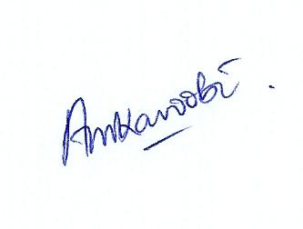Yours faithfully,



Alex Mukama

Director

Masterlinks Uganda Limited

PO Box 11644, Kampala

+256 780 566 688, +256 712 977 249

[masterlinksug@yahoo.com](mailto:masterlinksug@yahoo.com)

[www.masterlinksug.co.ug](http://www.masterlinksug.co.ug)

|  |
| --- |
| logo |
| **Quotation for the Procurement of video enhancement software:**  **UPF/SUPLS/19-20/CFC 000038** |
| **LOT 5** |

THIS QUOTATION IS SUBMITTED BY

MASTERLINKS UGANDA LTD.



**Response fact sheet**

|  |  |
| --- | --- |
| **Programme Title:** | Quotation for the procurement of video enhancement software.  Procurement reference: UPF/SUPLS/19-20/CFC 00038 (Lot 5) |
| **Key Organisers:** | Republic of Uganda, Uganda Police Force  Masterlinks Uganda Limited  Kinesense Limited |
| **Masterlinks Company Data:** | Company registered in Uganda: 29th March 2006  URSB Registration number: 79370  Uganda Revenue Authority TIN: 1000108869 |
| **Document date and Validity:** | 16th March 2020, valid until and including 12/06/2020 |
| **Document Status:** | Approved for submission. |

***Copyright 2020 Masterlinks Group Ltd. All rights reserved.***

*Neither this document nor any part of it may be copied or reproduced without the prior written consent of the Masterlinks Group Ltd. The information contained in this document is subject to change or revision without prior notice.*

*This proposal is valid until* ***12th June 2020,*** *or later by agreement.*

*Masterlinks Group Ltd. will be bound only by those terms and conditions that are agreed to in a formal agreement and final contract signed by Masterlinks Group Ltd. and the client and not by the information or absence of information contained in this document.*

*The Masterlinks Group comprises Masterlinks Uganda Ltd., Masterlinks Community Services Ltd. and e-Learner Uganda Ltd.*

.**Masterlinks Contact Information**

Physical Addresses:

4th Floor, Legacy Towers Suite 267

Kyadondo Road, Serena Conference Centre

Nakasero, Kampala, Uganda Kampala, Uganda

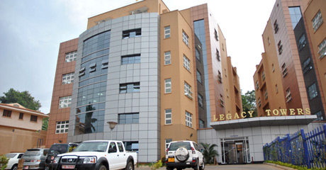

Postal Address: P. O. Box 11644, Kampala, Uganda

Contact Persons:

Alex Mukama Karoobi

+256 780 566 688 +256 712 977 249

[masterlinksug@yahoo.com](mailto:masterlinksug@yahoo.com)

Mike Watkins

+256 772 726 001

[Mikewatkins001@gmail.com](mailto:Mikewatkins001@gmail.com)

[www.masterlinks.co.ug](http://www.masterlinks.co.ug)

**Kinesense Contact Information**

Contact Person:

Ms Sarah Doyle

Physical Address: 79 Merrion Square

Dublin 2, Ireland

+353 166 24546

[info@kinesense-vca.com](mailto:info@kinesense-vca.com)

[www.kinesense-vca.com](http://www.kinesense-vca.com)

 4th Floor, Legacy Towers

Ministry of Education & Sports

Kyadondo Road, Nakasero

and, Suite 267 Serena Conference Centre

PO Box 11644

Kampala, Uganda

**Bid** **Submission** **Sheet**

*[Complete this form with all the requested details and submit it as the first page of your quotation, with the documents requested above attached. Ensure that your quotation is authorised in the signature block below. A signature and authorisation on this form will confirm that the terms and conditions of this RFQ prevail over any attachments. If your bid is not authorised, it may be rejected.]*

|  |  |
| --- | --- |
| Bid Addressed to (Procuring and Disposing Entity): | **Uganda Police Force.** |
| Date of Bid: | **16th March 2020** |
| Procurement Reference Number: | **UPF/SUPLS/19-20/CFC 00038 (Lot 5)** |
| Subject of Procurement: | **Procurement of Video enhancement software.** |

We offer to supply the items listed in the attached List of Supplies and Price Schedule and Specification and Compliance Sheet, in accordance with the terms and conditions stated in your Request for Quotations referenced above.

We confirm that we are eligible to participate in public procurement and meet the eligibility criteria specified in Part 1: Bidding Procedures.

We, including any subcontractors or providers for any part of the contract resulting from this procurement process, are eligible to participate in public procurement*.*

We have signed and undertake to abide by the Code of Ethical Conduct for Bidders and Providers attached during the procurement process and the execution of any resulting contract

Our bid shall be valid until and including **12/06/2020** and it shall remain binding upon us and may be accepted at any time before or on that date;

We confirm that the prices quoted in the List of Supplies and Price Schedule are fixed and firm for the duration of the validity period and will not be subject to revision or variation.

The delivery period offered is: **three weeks** from date of Purchase Order.

The warranty period offered is **(Not Applicable).**

**Bid Authorised By:**

|  |  |  |  |
| --- | --- | --- | --- |
| Signature: |  | Name: | *ALEX MUKAMA KAROOBI* |
| Position: | *DIRECTOR* | Date: | 16/03/20 |
| Authorised for and on behalf of: | |  | *Stamp- Police 16.jpg* |
| Company | *MASTERLINKS UGANDA LIMITED* | | |
| Address: | PO Box 11644, Kampala, Uganda | | |
|  |  | | |

**CODE OF ETHICAL CONDUCT IN BUSINESS FOR BIDDERS AND PROVIDERS**

(Under Section 93 of the Public Procurement and Disposal of Public Assets Act, 2003)

1. **Ethical Principles**

Bidders and providers shall at all times-

1. maintain integrity and independence in their professional judgement and conduct;
2. comply with both the letter and the spirit of-
3. the laws of Uganda; and
4. any contract awarded.
5. avoid associations with businesses and organisations which are in conflict with this code.
6. **Standards**

Bidders and providers shall-

1. strive to provide works, services and supplies of high quality and accept full responsibility for all works, services or supplies provided;
2. comply with the professional standards of their industry or of any professional body of which they are members.
3. **Conflict of Interest**

Bidders and providers shall not accept contracts which would constitute a conflict of interest with, any prior or current contract with any procuring and disposing entity. Bidders and providers shall disclose to all concerned parties those conflicts of interest that cannot reasonably be avoided or escaped.

1. **Confidentiality and Accuracy of Information**

(1) Information given by bidders and providers in the course of procurement processes or the performance of contracts shall be true, fair and not designed to mislead.

(2) Providers shall respect the confidentiality of information received in the course of performance of a contract and shall not use such information for personal gain.

1. **Gifts and Hospitality**

Bidders and providers shall not offer gifts or hospitality directly or indirectly, to staff of a procuring and disposing entity that might be viewed by others as having an influence on a government procurement decision.

1. **Inducements**

(1) Bidders and providers shall not offer or give anything of value to influence the action of a public official in the procurement process or in contract execution.

(2) Bidders and providers shall not ask a public official to do anything which is inconsistent with the Act, Regulations, Guidelines or the Code of Ethical Conduct in Business.

1. **Fraudulent Practices**

Bidders and providers shall not-

1. collude with other businesses and organisations with the intention of depriving a procuring and disposing entity of the benefits of free and open competition;
2. enter into business arrangements that might prevent the effective operation of fair competition;
3. engage in deceptive financial practices, such as bribery, double billing or other improper financial practices;
4. misrepresent facts in order to influence a procurement process or the execution of a contract to the detriment of the Procuring and Disposing Entity; or utter false documents;
5. unlawfully obtain information relating to a procurement process in order to influence the process or execution of a contract to the detriment of the PDE;
6. withholding information from the PDE during contract execution to the detriment of the PDE.

I **ALEX MUKAMA KAROOBI** agree to comply with the above code of ethical conduct in business.



*MASTERLINKS UGANDA LIMITED*

**AUTHORISED SIGNATORY NAME OF BIDDER/PROVIDER**



**Part 2: Statement of Requirements**

**List of Supplies and Price Schedule**

Procurement Reference Number: **UPF/SUPLS/19-20/CFC 00038 (Lot 5)**

Purchase Order Serial Number: ______________________________

*[Purchase Order Serial Number to be completed in the event of award of contract only]*

[Complete the currency of your bid. Complete the unit and total prices for each item listed below. Authorise the prices quoted in the signature block below.]

***Currency of Quotation:******Uganda Shillings***

|  |  |  |  |  |  |
| --- | --- | --- | --- | --- | --- |
| **Item No** | **Description of Supplies** | **Quantity** | **Unit of Measure** | **Unit Price** | **Total Price** |
| 01 | **Programming Software and license**  **(Video enhancement and investigation software** **for three users with three years license)** | 1 | Mulktiuser licence | 62,654,658 | 62,654,658 |
|  | * Should enhance images and videos from any source including body cameras, mobile phones and Social media platforms |  |  |  |  |
|  | * Identify important details like faces, Number plates |  |  |  |  |
|  | * Export files for court in any required format |  |  |  |  |
|  | * Conduct a proficiency Test to assure quality of image/Video |  |  |  |  |
|  | * Capable to restore, clarify, and analyze images and video in a simple, fast, and precise way. |  |  |  |  |
|  | * Designed based on investigative, forensic, military and security application need. |  |  |  |  |
|  | * Maintain the original evidence integrity. |  |  |  |  |
|  | * The video enhancement software should be open licensed or perpetual |  |  |  |  |
|  |  | | **Other additional costs** | | 0 |
|  |  | | **Subtotal** | | **62,654,658** |
|  | *Enter 0% VAT rate if VAT exempt.* | | **VAT @ %** | | **0%** |
|  |  | | **Total** | | **62,654,658** |

The Delivery and Completion Schedule shall be as specified in the Special Conditions of Contract.

**List of Supplies and Price Schedule Authorised By:**



Signed:

Name: *ALEX MUKAMA KAROOBI*

In the capacity of *DIRECTOR*

Duly authorised to sign the bid for and on behalf of: *MASTERLINKS UGANDA LIMITED*

**NOTE**: The currency exchange rate for buying Euros, according to the Bank of Uganda on Monday 16TH March 2020, the was: Euro 1.00 / Uganda Shillings 4126.15.

Prices quoted here are fixed during the performance of the Contract.

**Part 2: Statement of Requirements**

**Specification and Compliance Sheet**

Procurement Reference Number: **UPF/SUPLS/19-20/CFC 00038 (Lot 5)**

Purchase Order Serial Number: ______________________________

*[Purchase Order Serial Number to be completed in the event of award of contract only]*

*Complete column c with the specification of the supplies offered. Also state “comply” or “not comply” and give details of any non-compliances to the specification required. Attach detailed technical literature if required. Authorise the specification offered in the signature block below.*

| **Item No** | **Technical Specification Required** | **Compliance of Specification Offered** | **Technical literature on specification offered in column c** |
| --- | --- | --- | --- |
| ***a*** | ***B*** | ***C*** | ***D*** |
| 01 | **Programming Software and license**  **(Video enhancement and investigation software** **for three users with three years license)** | **Comply** | **The software is offered with an open / perpetual licence, for a single machine with unlimited users** |
|  | * Should enhance images and videos from any source including body cameras, mobile phones and Social media platforms | Comply | The software works with all current video formats, including data from body cameras, and many legacy formats. The software is updated as new formats appear on the market. |
|  | * Identify important details like faces, Number plates | Comply | Face identity and number plate recognition are included in the standard product, which is specified here.  Note that additional and separate modules are available, at extra cost, which include:  Face Detection & Attribution, which analyses video to find all faces in the video. These faces can then be filtered by:  • Filter faces by age  • Filter faces by gender  • Filter faces by wearing glasses/no glasses.  Also, an Automatic number-plate recognition (ANPR) Processing system will be available as a separately licensed product by end-2020 This will analyse video to detect licence plates, extract image of licence plate and OCR number to a file. |
|  | * Export files for court in any required format | Comply | Data is exported in a format specified by court authorities in each jurisdiction, for presentation to judiciary, using a storyboard approach. This is a standard feature used by clients around the world. Kinesense is the only known solution to provide all reporting tools in one platform conforming to the ISO 17025 international standard. |
|  | * Conduct a proficiency Test to assure quality of image/Video | Comply | As the software handles multiple video formats it automatically carries out tests to evaluate the quality of recorded video data. |
|  | * Capable to restore, clarify, and analyze images and video in a simple, fast, and precise way. | Comply | The main function of the software is to enhance the images captured from CCTV and other sources, and is easy and quick to locate footage of interest and provide court-ready documents. |
|  | * Designed based on investigative, forensic, military and security application need. | Comply | Kinesense software is designed and produced by international investigative experts, specifically for use by police and security services worldwide |
|  | * Maintain the original evidence integrity. | Comply | The integrity of the original evidence is maintained at all times. All enhancement operations take place using data extracted from the original source. |
|  | * The video enhancement software should be open licensed or perpetual | Comply | The software is licensed on an open / perpetual basis |

**Specification and Compliance Sheet Authorised By:**

|  |  |  |  |
| --- | --- | --- | --- |
| Signature: | Alex signature.jpg | Name: | **Alex Mukama Karoobi** |
| Position: **Director** |  | Date: | **16/03/2020** |
| Authorised for and on behalf of: | |  | *(DD/MM/YY)* |
| Company: | **Masterlinks Uganda Limited** | | |



**Part 3: Contract**

**General Conditions of Contract**

Any resulting contract shall be placed by means of a Government of Uganda Purchase Order and shall be subject to the Government of Uganda General Conditions of Contract (GCC) for the Procurement of Supplies (available on request) except where modified by the Special Conditions below.

**Special Conditions of Contract**

Procurement Reference Number: **UPF/SUPLS/19-20/CFC 00038 (Lot 5)**

Purchase Order Serial Number: ______________________________

*[Purchase Order Serial Number to be completed in the event of award of contract only]*

The clause numbers given in the first column correspond with the relevant clause number of the General Conditions of Contract.

| **Subject and GCC clause reference** | **Special Conditions** |
| --- | --- |
| **All subjects and clauses** | All subjects and clauses are duly noted. |

**ELIGIBILITY CRITERIA**

**The following documents are attached to confirm the Company’s eligibility to participate in public procurement.** Masterlinks Uganda Limited:-

1. has the legal capacity to enter into a contract;

*A certified Powers of Attorney is attached*

**

**

1. is not insolvent, in receivership, bankrupt or being wound up or subject to legal proceedings for any of these circumstances;

*A letter of confirmation is attached*

 4th Floor, Legacy Towers

Ministry of Education & Sports

Kyadondo Road, Nakasero

and, Suite 267 Serena Conference Centre

PO Box 11644

Kampala, Uganda

Uganda Police Force

Procurement and Disposal Unit,

P.O. Box 7055

Plot No. 66/68 Jinja Road, Estates Building

1st Floor Room 20

Kampala, Uganda

16th March 2020

**Attention: Head-PDU**

**RE: UPF/SUPLS/19-20/CFC 000038 (Lot 5)**

This letter serves to confirm that Masterlinks Uganda Limited is not, nor has been:

* insolvent, in receivership, bankrupt or being wound up or subject to legal proceedings for any circumstances;
* subject to suspension by the Public Procurement and Disposal of Public Assets Authority.

Yours faithfully,



Alex Mukama

Director

Masterlinks Uganda Limited

PO Box 11644, Kampala

+256 780 566 688, +256 712 977 249

[masterlinksug@yahoo.com](mailto:masterlinksug@yahoo.com)

[www.masterlinksug.co.ug](http://www.masterlinksug.co.ug)

1. has not had business activities suspended;

*A current business licence from KCCA is attached*



1. has fulfilled obligations to pay taxes and social security contributions;

*A Tax Clearance Certificate is attached*

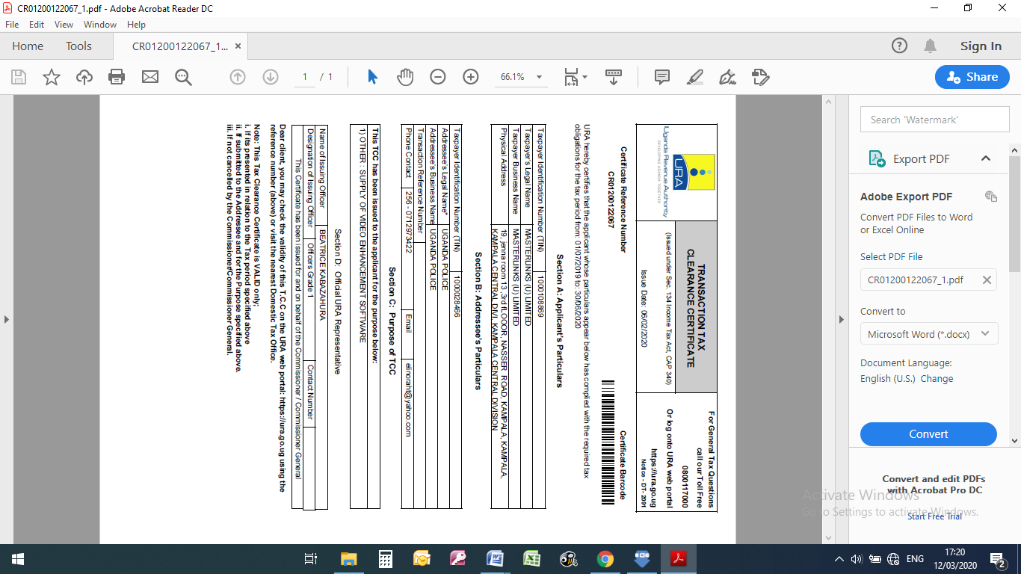

*A Registration / Clearance Certificate from NSSF is attached*

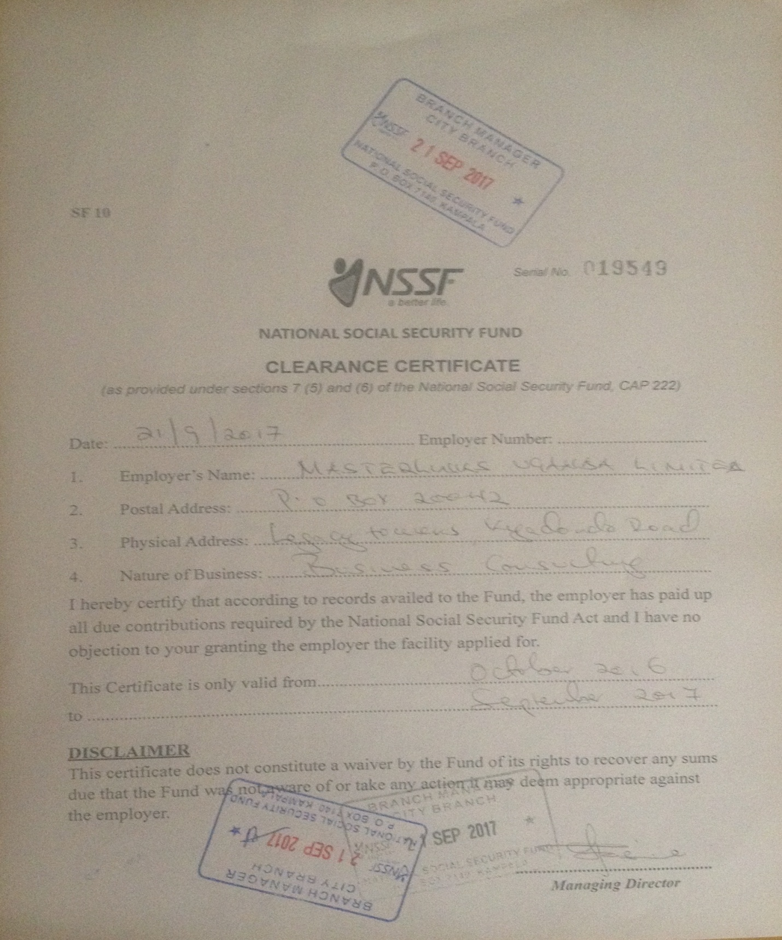

1. has the nationality of an eligible country, as defined in the Special Conditions of Contract;

*Section 5: A completed Eligible Countries statement is attached below*

***Section 5: Eligible Countries***

**Procurement Reference Number: UPF/SUPLS/19-20/CFC 000038 (Lot 5)**

All countries are eligible except countries subject to the following provisions.

A country shall not be eligible if:

(a) as a matter of law or official regulation, the Government of Uganda prohibits commercial relations with that country, provided that the Government of Uganda is satisfied that such exclusion does not preclude effective competition for the provision of supplies or related services required; or

(b) by an act of compliance with a decision of the United Nations Security Council taken under Chapter VII of the Charter of the United Nations, the Government of Uganda prohibits any import of Supplies from that country or any payments to persons or entities in that country.

***NOTED:*** *countries associated with this bid are:*

* *The Republic of Uganda,*
* *The Republic of Ireland,*
* *The United Kingdom of Great Britain & Northern Ireland.*

1. does not have a conflict of interest in relation to this procurement requirement; and

*This is confirmed in the authorised CODE OF ETHICAL CONDUCT form, attached above.*

1. is subject to suspension by the Public Procurement and Disposal of Public Assets Authority (the Authority).

*A letter of confirmation is attached above.*

**Documents Evidencing Eligibility**: Bidders shall submit the following documents:

1. a certificate of registration issued by the Authority for bidders currently registered with the Authority or a copy of the Bidder’s Trading licence or equivalent and a copy of the Bidder’s Certificate of Registration or equivalent for bidders not currently registered with the Authority;

*A Certificate of Registration is attached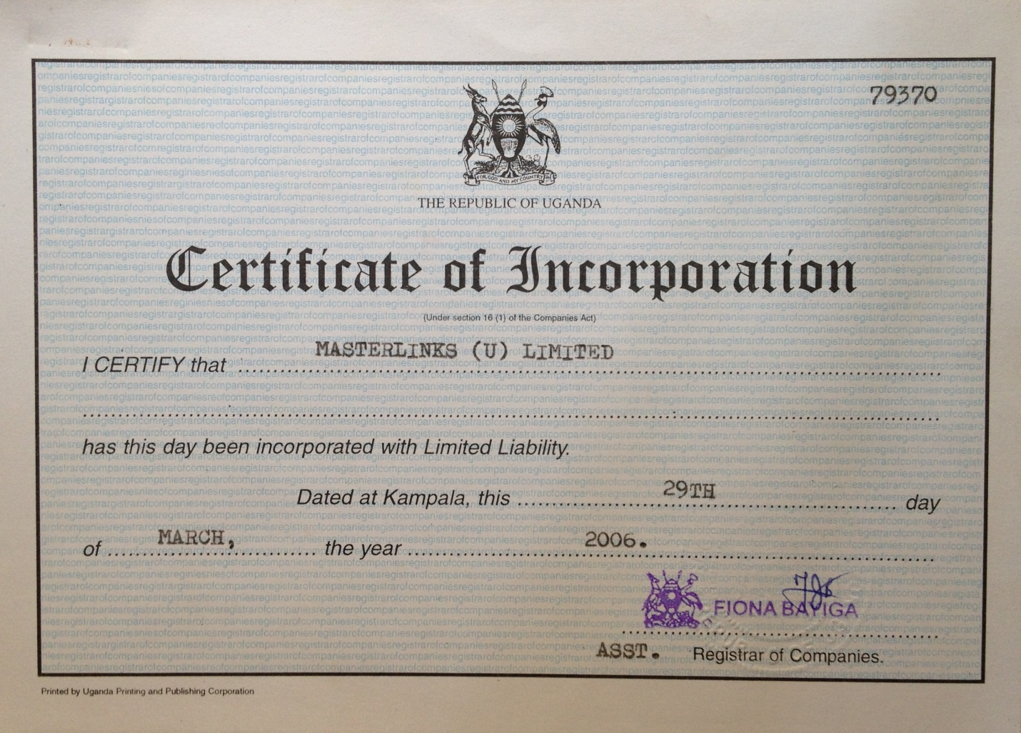*

1. Evidence of fulfilment of obligations to pay taxes and social security contributions in Uganda where applicable

*A Tax Clearance Certificate is attached above*

1. Any other relevant documentation.

*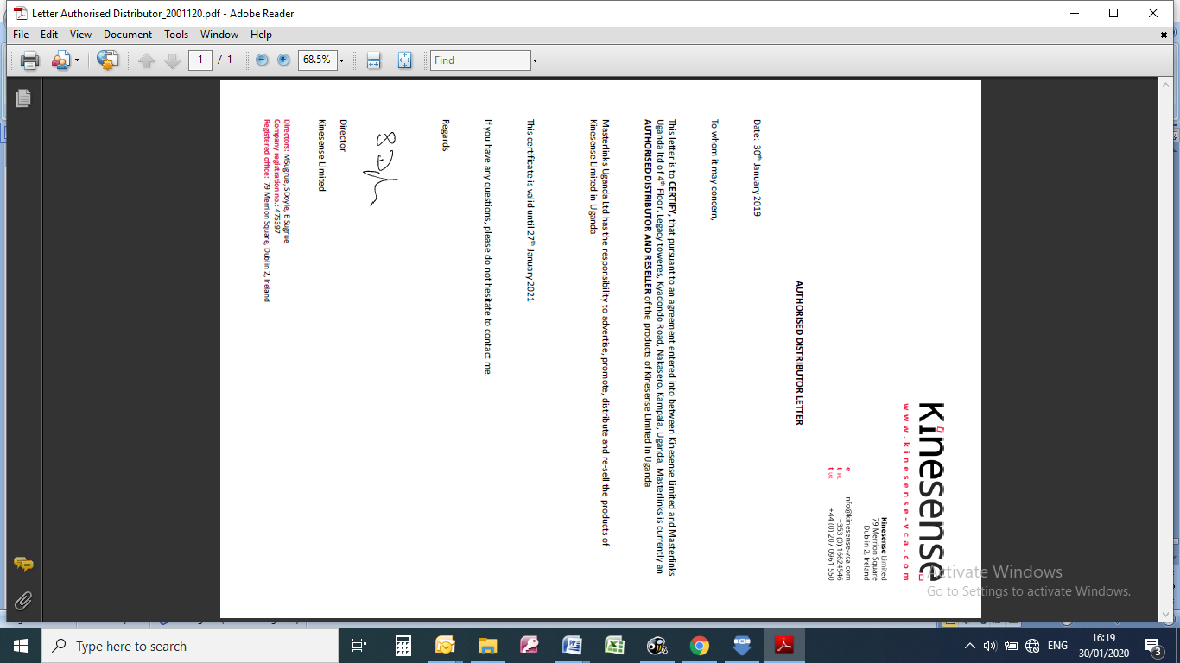Confirmation of a product Distribution Agreement is attached*

*A Registration Certificate from PPDA is attached*

**